VEHICLES AND TRANSPORT

- Complete each sentence with a word from the box.
- The company chairman has a Rolls-Royce driven by a chauffeur.
- When my car broke down a passing ________________ towed it to a garage.
- The police wanted me to describe the ________________ of the car.
- The four passengers on the ship had dinner with the ________________.
- The train couldn't leave until the ________________ waved his green flag.
- Hilary was given a parking ticket by a ________________.
- Before take-off, the ________________ told me to fasten my seat belt.
- When I got on the ship, one of the ________________ helped me find my cabin.
- There isn't a ________________ on this bus, you pay the driver.
- Eddie is a keen ________________ and rides his bike to work every day.
- The bus mounted the pavement and injured a ________________.
- Jim works as a ________________ in a local garage.
- Complete the labels with suitable words from the box
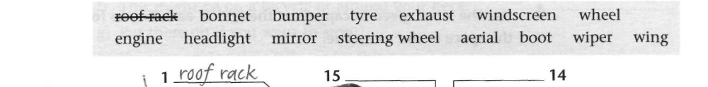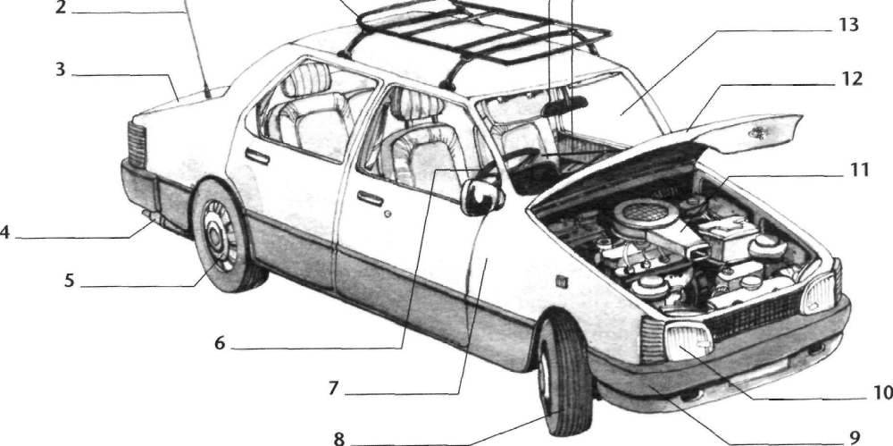

III. Choose the most suitable word or phrase to complete each sentence.
- The ship stopped because two passengers had fallen (upside down/overboard/underground/inside out).
- The (platform/quay/runway/pavement) was crowded with passengers waiting for the train.
- We had to stop for petrol at a filling (garage/service/pump/station).
- Mary looked up the fastest train to Glasgow in the (catalogue/timetable/dictionary/programme).
- The train was very crowded because there were only four (coaches/wagons/trucks/cars).
- Peter's car (crashed/collided/hit/skidded) off the icy road and fell into a ditch.
- I dropped my wallet from the boat but luckily it (drifted/floated/sank/rescued).
- Everything went dark when the train entered a/an (underground/tunnel/tube/metro).
- David missed his train because of the queue in the ticket (office/agency/room/lounge).
- To get to our hotel we had to cross the railway (road/route/rails/line).

IV. Use the word given in capitals to form a word that fits in the space.
A letter of apology
I am writing to apologise for the (CANCEL)______________ of your Happy Holiday Coach Tour to Aberdeen. (FORTUNE)______________ our luxury coach was involved in a (COLLIDE)______________ in France a week ago,
and our driver has been (EXPECT)______________ obliged to remain there for the moment. The coach was travelling on a road (SUIT)______________ for heavy traffic, and the accident was (AVOID)______________. Luckily none of the passengers suffered any (INJURE)______________, and we have complained to the authorities that the road needs (WIDE)______________. Our new coach will be fitted with (ADJUST)______________ seat belts for the safety and comfort of passengers. We will of course return the (PAY)______________ you have made for your holiday as soon as possible.

V. Complete each sentence with sail or ship, or a word formed from one of these words.
- Jack has been working as a _______________ for ten years.
- We're all flying home but our furniture is being _______________.
- What time does the ferry set _______________?
- We are expecting a _______________of coffee from Brazil this week.
- We have decided to go for a _______________ tomorrow afternoon.
- When Paul was young, he _______________ round the world.
- It's time you were aboard _______________. We're leaving soon.
- Do you like _______________? Or do you prefer water-skiing?
- Graham works in the harbour as a _______________ clerk.
- The boats on the lake had brightly coloured _______________.
VI. Match the words in the box with a suitable description (a-j).
- An aeroplane has two of these. wings
- Change this in a car to change speed. ____________
- Hold these when you ride a bicycle. ____________
- This will save your life if you fall from a plane. ____________
- You need these to row a boat. ____________
- This might be on a bicycle or around your neck. ____________
- Put these on if you want to stop. ____________
- Your car engine is usually under this. ____________
- Walk on this when you are on a ship. ____________
- The pilot of a plane sits in this. ____________
VII. Complete each sentence with one suitable word.
- I'm really_____________ forward to sailing in Jean's new yacht.
- In cities, cars and other vehicles ______________ up most of the space.
- We'll come with the van and ______________ up the rest of the furniture.
- When the storm began, the small boat ______________for the nearest harbour.
- How can you ______________up with all those exhaust fumes!
- We can't ______________ up with that speedboat in this rowing boat!
- Jane likes ______________ off by driving her sports car at 100 miles an hour.
- A fire engine arrived and soon ______________ out the fire.
- Little Johnny is in the garden ______________ out his new tricycle.
- One way of ______________ with pollution is to use unleaded petrol.
VIII. Decide which answer (A, B, C or D) best fits each space.
Past, present and future
A hundred years ago, most people travelled (1)_____ foot, by train, or on horseback. (2)_____ had made it possible to travel rapidly over long distances. Bicycles were also becoming (3)_____, after the invention of the air-filled (4)_____, which made cycling a lot more comfortable. Buses, trams and (5)_____ railways had already been invented, and cities all over the world already had traffic (6)_____. There were very few private cars, and city (7)_____ were still full of horses. What a difference a hundred years have (8)_____ ! (9)_____ we have got (10)_____ to the problem of private cars, and some cities are so noisy and (11)_____ that in many places (12)_____ have been banned from the city centre. How will we be travelling in a hundred years' time? Perhaps (13)_____ then there will be only personal helicopters. There may be no need to (14)_____ to work or school in the future, since everyone will have a computer at home. There might even be more people walking and horse-riding, for pleasure and (15)_____.
1) | A by | B on | C with | D to
2) | A Tracks | B Lines | C Ways | D Railways
3) | A popular | B invented | C then | D handlebars
4) | A boot | B brake | C tyre | D engine
5) | A metro | B buried | C underground | D submerged
6) | A blocks | B sticks | C knots | D jams
7) | A streets | B pavements | C lawns | D carts
8) | A taken | B done | C made | D got
9) | A Presently | B Nowadays | C Then | D Later
10) | A more | B them | C motorists | D used
11) | A even | B polluted | C so | D poisoned
12) | A vehicles | B traffic | C transport | D trips
13) | A cars | B by | C even | D transport
14) | A have | B transport | C decide | D commute
15) | A exercise | B keep fit | C energy | D healthy

